Sarah Drasner is a well-known developer in the Vue.js community and does a lot of work on the website CSS Tricks. The first thing that hit me about the homepage of her personal website is that it emphasizes one of the subjects for which she is most known, SVG animations.

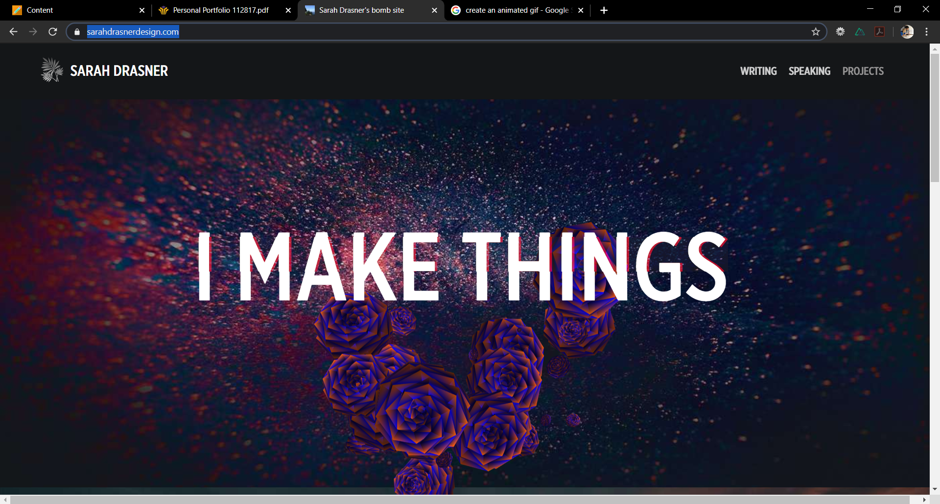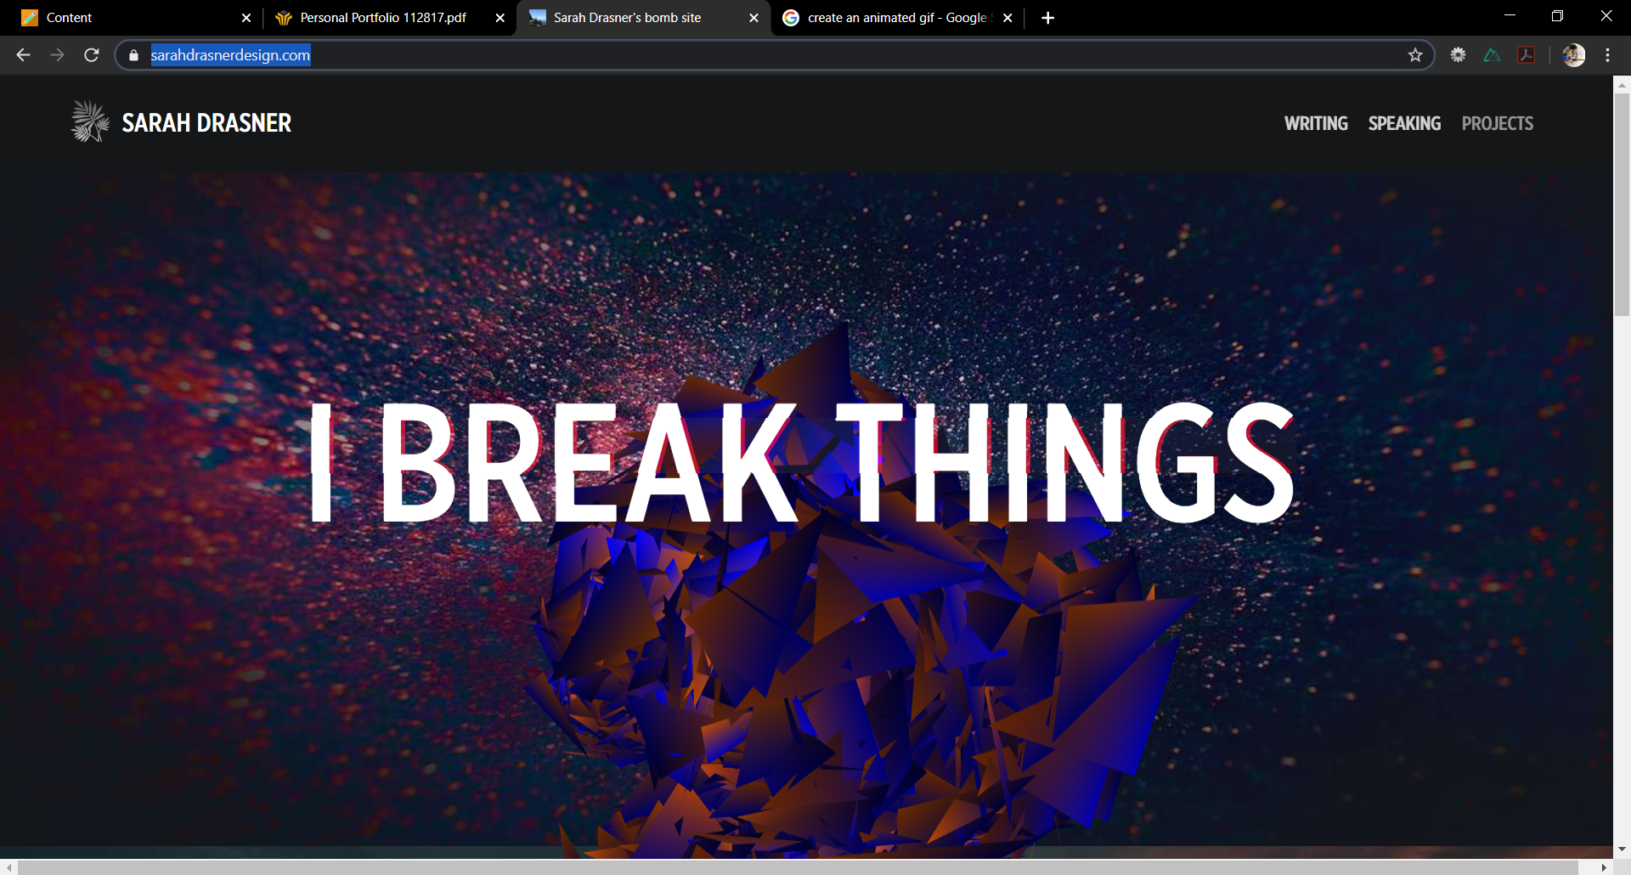

The above screenshots are taken from an animation triggered by hovering over the words “I MAKE THINGS”. Additionally, there is an impressive flickering effect on the banner letters, which is a nice touch. One conclusion I draw from this is that your personal web portfolio should, both in it’s examples and in it’s overall design, be a reflection of your overall skills as a developer.

Brad Frost, the author of Atomic Design, has another good personal website. Under his “frontend design” link he showcases screenshots from homepages of previous design projects which serve as links to those actual sites, such as the one in the screenshot below: 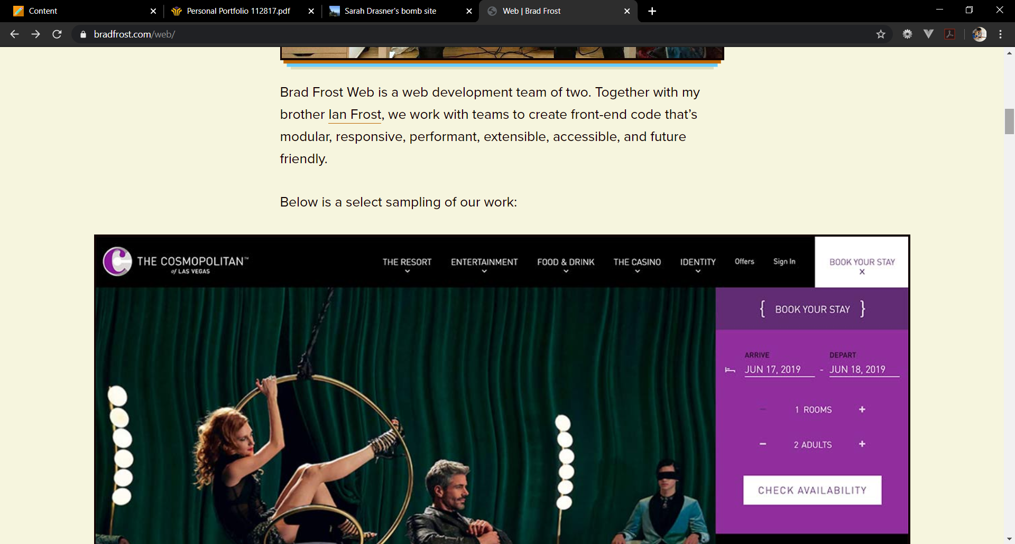

Again, not only are these great examples of his skills, but the fact that they are operational websites gives visitors the oppourtunity to explore for themselves and get a feel for his work. Obviously he has been at this for quite some time, and I won’t have a body of work like this to draw on, but the principle I’m drawing is the importance of the functionality on display. If users can click on things, interact with things, then they are more likely to stay on the site for longer. This can only be a good thing.

The last personal web portfolio I’m using is from Scott Tolinski, who is a co-host of the Syntax podcast. His homepage is simple in its layout, but extremely impressive, nonetheless. The background image is a 30 second video that looks great, the animations are crisp, and there is a prominent bar at the bottom with links to his various projects and social media accounts. The overall theme is extremely successful and so the main idea I’m taking away is that the personal portfolio site should have a strong design, just like any other website. If I’m trying to showcase my skills doing this, then it should start with the design and implementation of my own site.

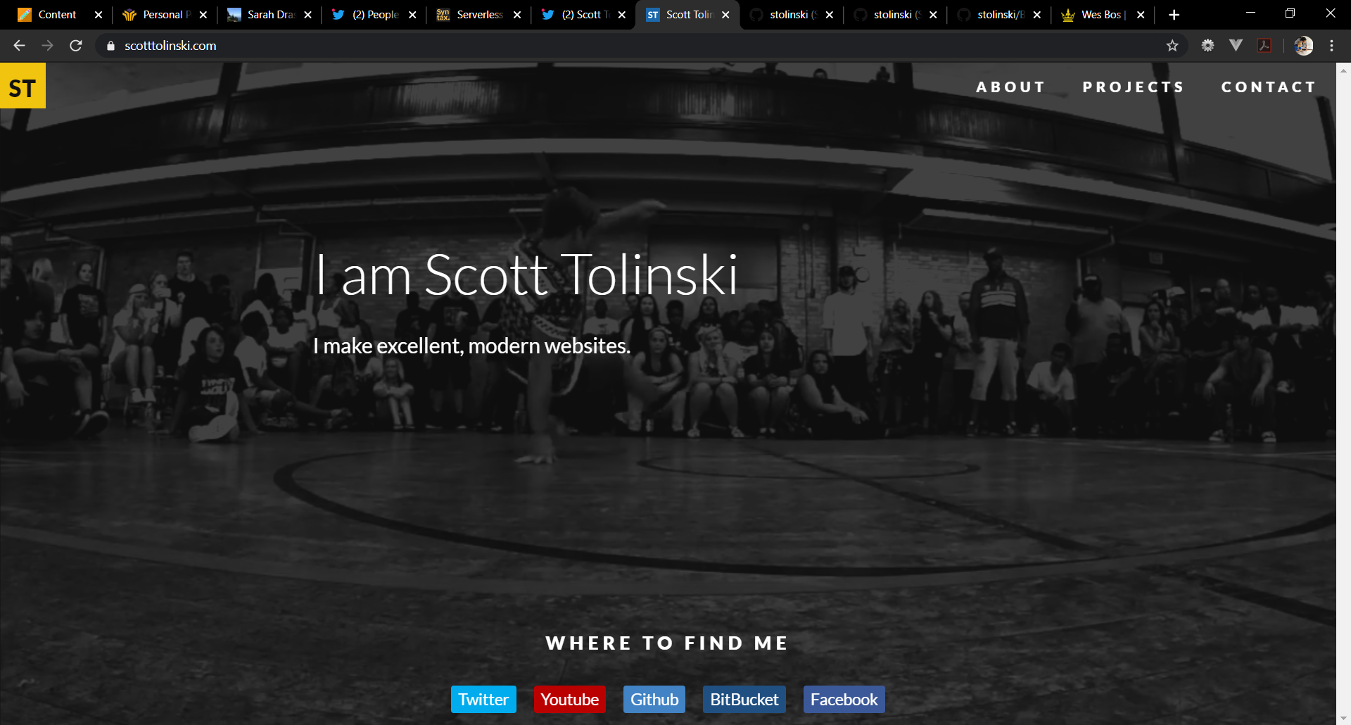

Works Cited:

<https://sarahdrasnerdesign.com/>

<https://bradfrost.com/web/>

<https://www.scotttolinski.com/>